Tuesday
Art: Texture Treasure Hunt
Today we are going to go on a special treasure hunt around our house to find different textures to use in our artwork.
What does ‘texture’ mean?
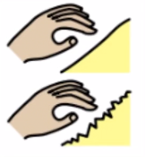

Texture is how something feels when you touch it. How do different items in your house feel? What things are bumpy? Soft? Rough?

Artist focus: Max Ernst
Max Ernst was born in 1891 and died in 1976. He was a German surrealist painter, which means that he painted pictures that were considered a little bit ‘weird’ or dreamlike. He invented the technique we’re going to look at today called frottage. Frottage is the technique of creating rubbings by placing a page over a textured object and rubbing and colouring pencil or a crayon over the top of it.
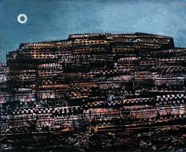

In this painting, ‘The Entire City’, Ernst used frottage to create texture in a surreal city.
What does it look like to you? Have a close look and see what you can find.

Challenge: Texture Treasure Hunt
Equipment:
- A4 paper (plain or lined- whatever you have!)
- A sharp pencil
- Colouring pencils (optional)
- A black felt marker (optional)
Instructions:
Create a frottage patchwork from rubbings of textured objects which you find around your home.
- Fold your paper into 16 sections. (Fold in half carefully lengthwise, then half again. Unfold. Repeat widthwise.)
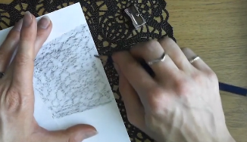
- Put your first textured item under your paper and decide which area you want to put your frottage in (one section of your folded paper). Using the side of the pencil lead, rub your pencil over the section.
- Repeat for each section of your paper, using different textures for each section.

