Wednesday
History: Henry VIII (Lesson 5)
Henry’s Great Matter
Can you remember some of the new vocabulary we have encountered in our study of Henry VIII?
- Divorce
- Dynasty
- Vivacious
- Valid
- Smitten
- Null and void
- Headstrong
How many did you remember?
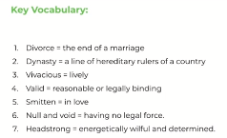
Vocabulary Activity
Choose the word that would fir in the gap and write out the full sentence.
Divorce dynasty smitten headstrong reform
- The debate about ___________ of the House of Lords is centuries old.
- Her mother always told her she was extremely _______ because she never listened and always did exactly as she pleased.
- Julius Caesar was _____________ with Cleopatra from the moment he first laid eyes on her.
- The Julio-Claudian ___________ ruled ancient Rome for over a hundred years.
- Prince Charles and Princess Diana had a very acrimonious __________.
Vocabulary activity:
Now write your own sentence for each of the following words and phrases:
- Divorce (noun)
- Dynasty (noun)
- Vivacious (adjective)
- Valid (adjective)
- Smitten (adjective)
- Null and void (adjective)
Questions:
- Who led the Reformation Parliament?
- What was the 1534 Act of Supremacy?
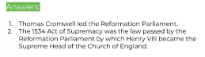
Key words and concepts:
What can you remember about these key words and concepts?
- Pope
- Protestant
- Catholic
- Church of England
- Reformation Parliament (1529-1536)
- Reformation
- Supremacy Act of 1534
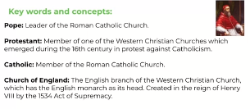
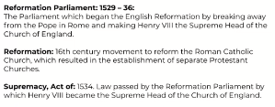

What can you remember about these people?
- Thomas Cranmer
- Thomas Cromwell
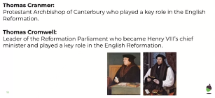

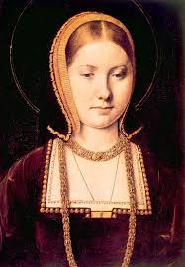
Postscript

Catherine was sent away from court and was refused access to her daughter, Mary. She died broken-hearted, in January 1536.
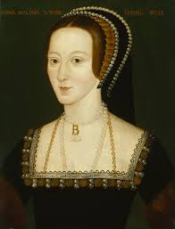

Anne’s child turned out not to be the longed-for son, but a daughter, Elizabeth. Henry’s marriage to Anne was short and troubled. Anne was beheaded for treason in 1536.

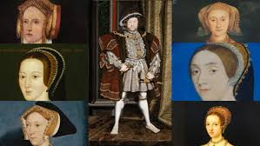
Henry went on to marry four more times. He did eventually have a son, Edward, by his third wide, Jane Seymour, but Jane died soon after the baby was born. Henry called his fourth wife, Anne of Cleves, ‘The Flanders Mare’. He took an instant dislike to her and divorced her as quickly as he could. Anne Boleyn was not the only wife to lose her head, the same fate occurred to Henry’s fifth wife, Catherine Howard, who was only nineteen at the time of her death. Henry was by then an over-bearing tyrant. He died in 1547. Through a combination of luck and good judgment, his sixth wife, Catherine Parr, managed to outlive him.

Questions:
- Who were Henry’s 3 children?
- What were the names and respective fates of Henry’s six wives? (think about the rhyme!)
