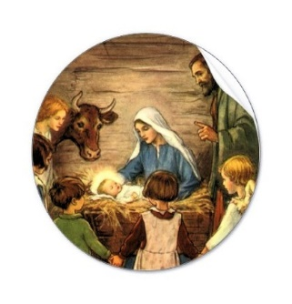
All Saints’ Church, Upper Norwood

Dear Friends,

I hope this letter finds you well. I am listing below a slight change in our service pattern during the winter months; and giving details of our Advent and Christmas services. The Church is fully compliant
in working with the Covid-19 health and safety regulations, so I hope you will feel it safe to attend a service on Sunday; and our Advent and Christmas services.

Sundays: Morning: 10:00 am Parish Communion (Mass) Evening: 6:00pm Holy Communion (Book of Common prayer)
Tuesdays: Evening: 7:30pm Mass
Saturday: 1st of month: 10:00am Mass

Services for Advent and Christmas

Sunday: 20 December 6:00pm Christmas Carols & Readings (wrap up warm – outside weather permitting!)

Christmas Eve Thursday 24 December:

Crib Service 6:00pm all welcome, particularly the young! Children are invited to take the Nativity figures to the crib. Weather permitting Carols will be sung outside – wrap up warm. Lasts 25 minutes.)

Midnight Mass at 11.30pm

Christmas Day Friday 25 December: First Mass of the Morning 10.00am

New Year’s Eve Thursday 31 December – The Naming of Jesus and Crossover Mass 11:00pm
As this year draws to a close I am mindful of the impact Covid 19 has had on many people. Families whom have lost loved ones, not just to Covid, but also in other very sad circumstances. I am available to anyone who might find it helpful to have a listening ear. Please do not hesitate to contact me. My details are below. This comes with my love and best wishes to you as we welcome the Christ child into our hearts and our homes this Christmas. Yours in Christ, Fr Leonard.

E: leonard.marsh@yahoo.co.uk T: 020 8653 2820

