News from your school’s Mental Health Support Team (MHST)
w/c 1st February 2021
Dear Parents & Carers,
As we enter the 5th week of school closures, we hope that you are all doing as well as can be expected. We are writing to let you know details of our upcoming workshops and share some resources that may be of support during these difficult times.

Upcoming workshops for parents / carers and young people
We’re running the following free workshops for parents / carers, and young people this half term. Please sign up with Eventbrite using the links below:

Workshops for parents / carers
Thur 4th Feb 10:00 Supporting anxious children during lockdown https://tinyurl.com/anxiouschildren-4Feb
Workshops for young people (aged 11- 18)
Wed 3rd Feb 16:00 Managing your anxiety during lockdown https://tinyurl.com/managinganxiety-3Feb
Wed 24th Feb 16:00 How to keep calm during lockdown
Link to follow in future newsletters

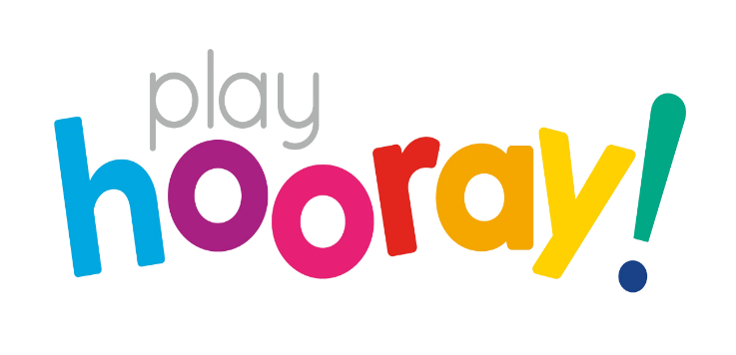

Useful resources
We have found this blog to be really useful for parents that are homeschooling their children at the moment. There are lots of creative ideas and resources and they are all free to download:
https://playhooray.co.uk/blogs/news/play-for-all-ages

Further support for parents / carers
In addition to the workshops, we are also offering individual support for parents / carers of children struggling with either anxiety or challenging behaviour:
One-to-one support for parents / carers of children aged 5-11 struggling with anxiety
Anxiety, fears and worries are normal experiences that we all have from time to time, but sometimes they interfere with our lives. As a parent / carer it can sometimes be difficult to know what to do for the best.
One-to-one support for parents / carers of children aged 5-8 experiencing behaviour problems
We know how difficult being a parent can be, and sometimes parents / carers need some support to manage their child’s challenging behaviours, break unhelpful patterns of behaviour, and improve your relationship with your child.

Requests for one-to-one support can be made through your school, or you can email us directly on MHST@croydondropin.org.uk or call on 07736 043796.
